Just like TMS you would be able to add as many search by options as needed

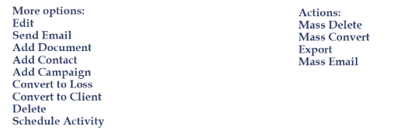

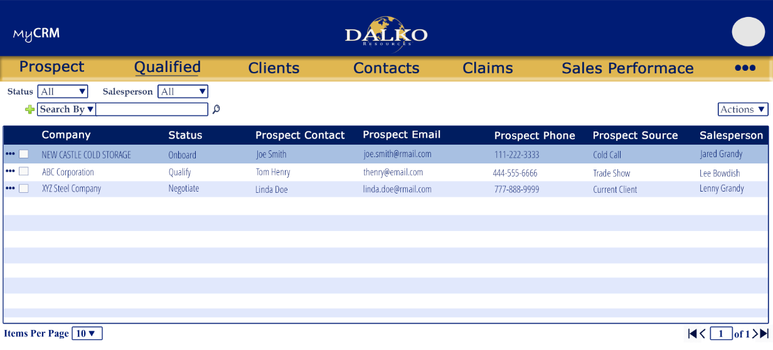

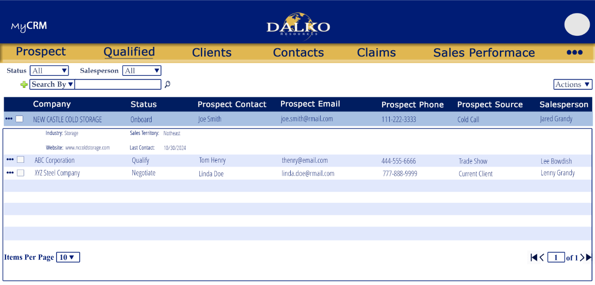
New/Edit
Unlike the current CRM you would not have to click to edit each field. Instead all fields would be open to edit, we would add a Save button and the button would be permission based. That would allow certain users to view details but not save the changes.

If a contact is added in this screen is will also be added to the Contacts screen and vice versa
If a Activity is added in this screen is will also be added to the Activities screen and vice versa (if we have one)
If a campaign is added in this screen is will also be added to the Campaigns screen and vice versa
If a contact log is added under the Contact it will also be added under Contact log on this screen and vice versa

Activities More menu Options:


